E-mail to Families
Suggested Copy

Subject: Class of 2025 College Planning Virtual Event – Tuesday, September 19

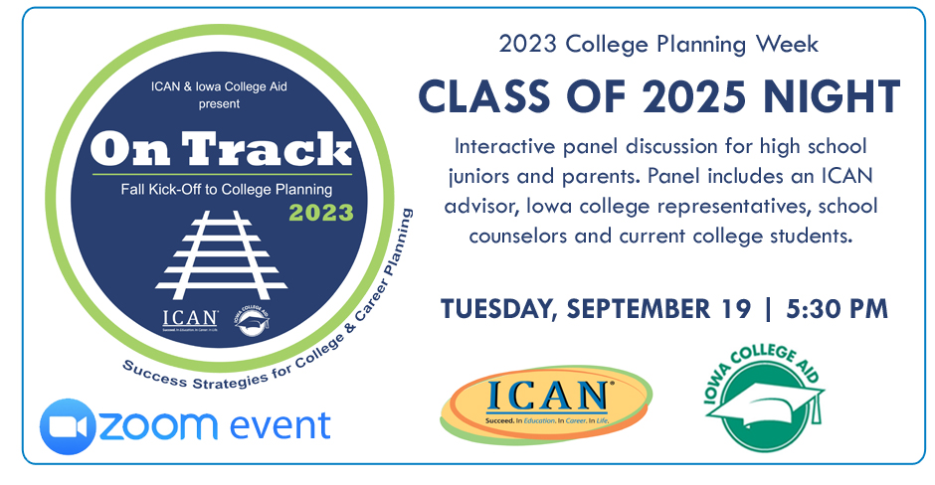

Please plan to attend the On Track Class of 2025 event on Sept. 19. On Track is a virtual event series hosting interactive panel discussions for students and parents by grade-level, so you get only the information you need for your current planning needs.

The panel consists of planning experts, Iowa college representatives, and school counselors. Joining the panel will also be current college students to share their experiences and advice with today’s high school students.

The junior event will focus on exploring colleges through campus visits and college fairs, post-high school education and training options, scholarship prep, and action steps you can take now to help prepare you for college admissions. Bring your questions and join us.
Back on Track - Class of 2025 Virtual Event
Tuesday, September 21, 2023
5:30 – 6:30pm
Register: https://us06web.zoom.us/webinar/register/WN_7BfCkz_-ST-6gmTSDLsLvQ#/registration
The event is FREE. Visit www.icansucceed.org/ontrack for all the event details and to register to attend.

