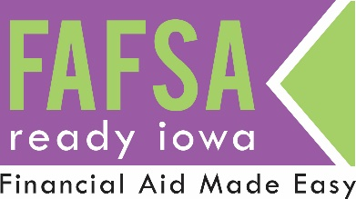
FOR IMMEDIATE RELEASE

Media Contact:
<<Site Coordinator>>
<<Title>>
<<Phone Number>>
<<Email>>

*** MEDIA ADVISORY ***

Iowa Students Receive Free Assistance with
Financial Aid for College <<Next Day of the Week>>

<<Your City>>, IOWA (<<date one week before event>>, YEAR) — Next <<Day of the Week>>, Iowa students and families will receive free assistance with the Free Application for Federal Student Aid (FAFSA), the federally required form for students who want financial aid for college.

WHEN: <<Date>>
<<Time>>
<<Room Location>>

WHERE: <<Location>>
<<Address>>

# # #

About FAFSA Ready Iowa
The FAFSA Ready Iowa is part of the national Fund Your Future FAFSA awareness campaign. FAFSA Ready Iowa is an initiative creating a network of assistance events to increase access to financial aid. The program is organized and run by ICAN with support from Iowa College Aid, Iowa School Counselor Association (ISCA), the Iowa Association of Financial Aid Administrators (IASFAA), as well as Iowa schools, colleges and universities. Learn more at www.ICANsucceed.org/FAFSAreadyia.

